**Step 1: Go to the website trenitalia.com and select your trip:**

* Departure
* Arrival
* Date
* Time
* Passengers
* **SEARCH**

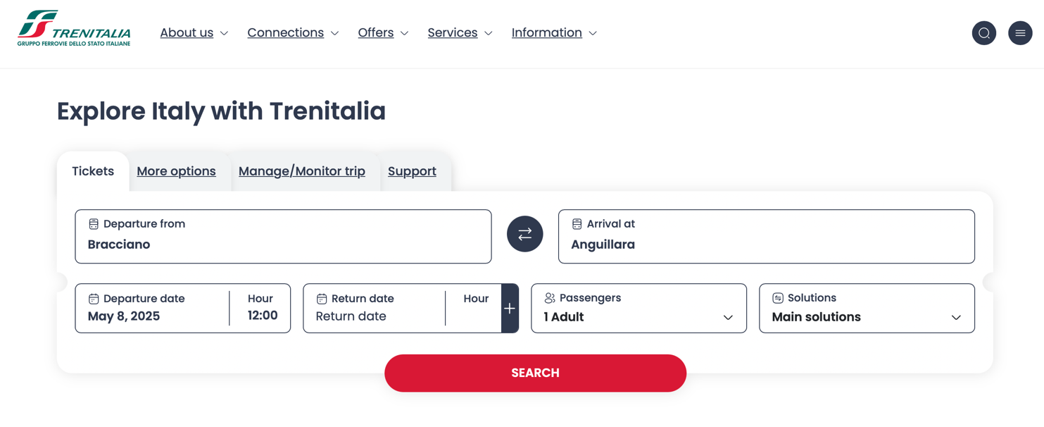

**Step 2: Select the travel option you prefer**

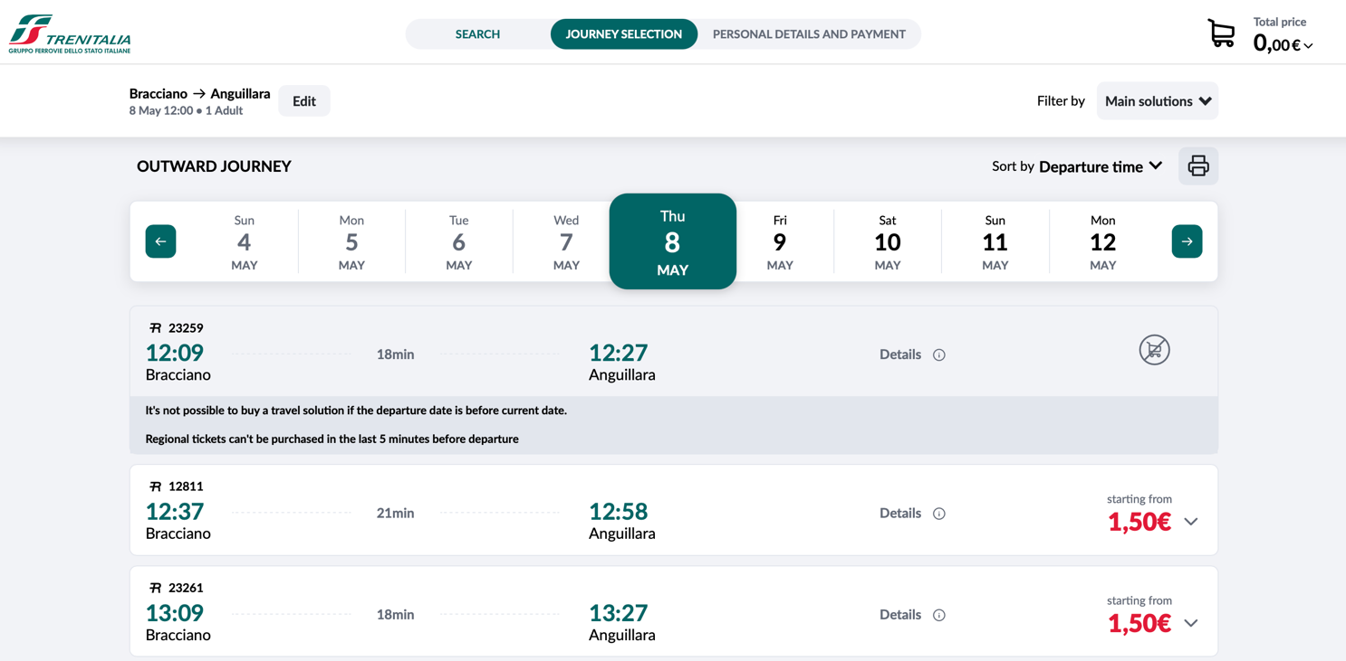

**Step 3: Click on SEE MORE OFFERS**

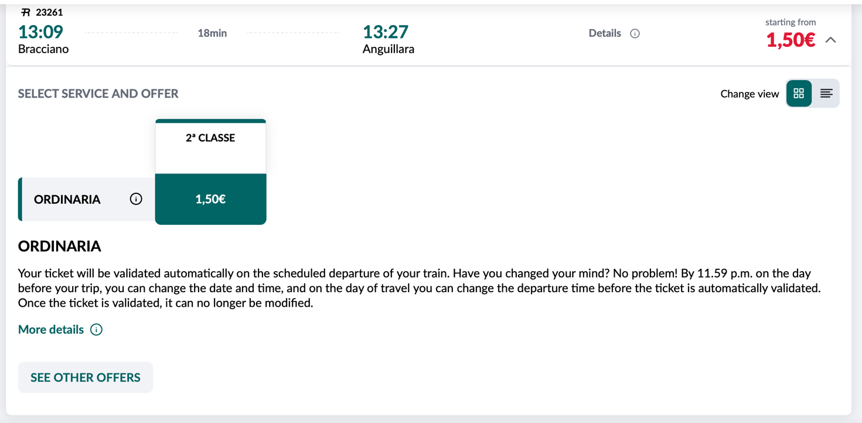

**Step 4: Select the Vie Francigene offer**

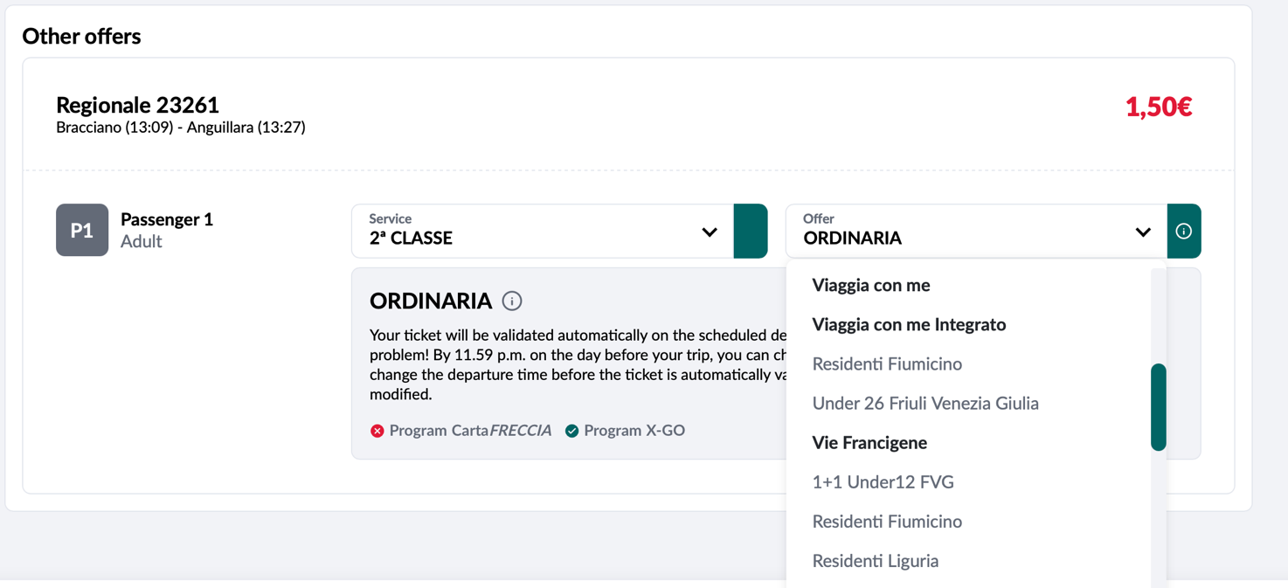

**Step 5: Enter your credential code and complete the purchase**

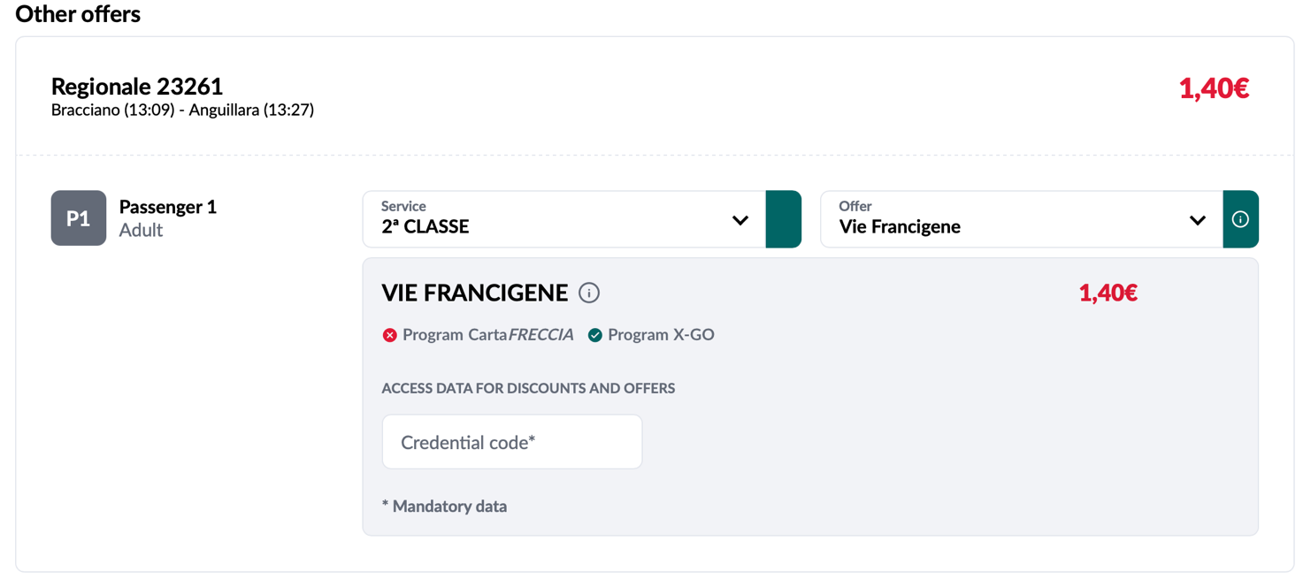

**IMPORTANT  
You must carry your pilgrim credential with you during the train journey, as the ticket will display its numeric code, confirming the validity of the offer.**